LED Laser Effect Light

User Manual

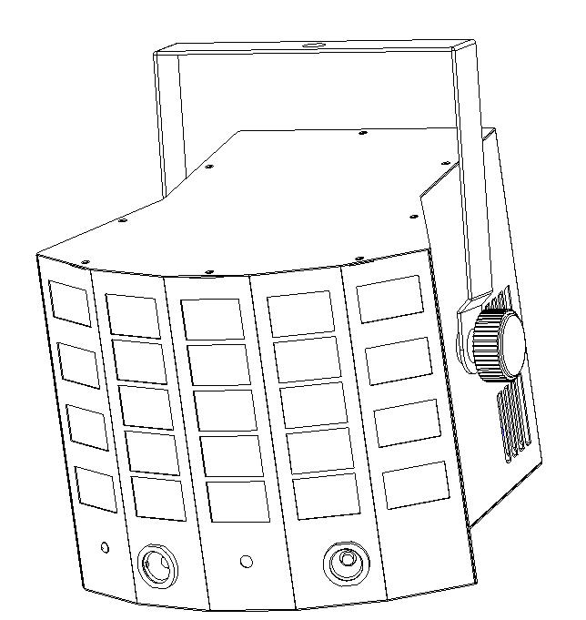

Please keep read this manual carefully for further use!

Content

Spare part, cautions---------------------------------------------------------------- P2

Silkscreen symbol------------------------------------------------------------------- P3

Safety/installation/specification-------------------------------------------------- P4

LED Display and MENU operation----------------------------------------------- P5

DMX Channel-------------------------------------------------------------------------- P6

Instation-------------------------------------------------------------------------------- P7

Installation------------------------------------------------------------------------------P8

DMX connection and DMX address setting ------------------------------------P9

Product size/ Declaration--------------------------------------------------------- P10

Warranty card------------------------------------------------------------------------- P11

Thank you for purchasing our Gobo derby light. Please read user guide for safety and operations before using. Keep this manual for future reference.

This unit has been tested at our factory before being shipped to you, there is no assembly required.

Once after received this product , please take and put carefully. And check cautiously that whether the product was damaged or not during the transportation.

Spare part includes:
Parts | Qty | Units
Light | 1 | pc
User manual | 1 | pc
Power cable | 1 | pc

Cautions
Before delivery, this device has passed strict inspection, Please follow the user manual strictly for operation, if this fixture is damaged by improper operation and mistake, the fixture will be out of warranty, and manufacture or dealer won’t be responsible for it. In case of any technology change in this manual,we won’t advise in further .



CAUTION!

Keep this device away from rain and moisture!

Unplug mains lead before opening the housing!

Warning!

Silkscreen symbol on light
Damages caused by the disregard of this user manual are not subject to warranty. The dealer will not accept liability for any resulting defects or problems.

Silkscreen symbol

-----------------------------------------------------------------------------CE certificate

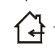

------------------------------------------------------------------------Only indoor using



---------------------------------------------------------------------------RoHS certificate

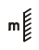
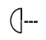
---------------------------The minimum distance from lighted objects(meter)

--------------------------------------------------------------Max ambient Temp

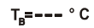
------------------------------------------------------------Max housing Temp


------------------------------------------------------------------------- Safety caution


----------------------------------------------------------------------Be careful of burn



----------------------------------------------------------------------Danger high voltage

-------Not allow installation directly on the surface of ordinary combustible materials

1. Safety instruction
- Once after received this product , please take and put carefully. And check cautiously that whether the product was damaged or not during the transportation, if yes, please not use this fixture and contact local dealers or manufacturers as soon as possible.
- The applicable temperature for the lighting is below 40°C. Do not use the lighting above the temperature.ta=40℃
- The fixture applicable widely, it must keeping clean, Please do not in overheat or dusty environment use the device. Do not touching Chemical liquid.
- Should be paid attention to the use of this product: fire, heat, electric shock, loss caused by severe or fatal injury, in electricity or to read the instructions before installation, follow the safety instruction and pay attention to the manual and warning signs on the equipment, if you have any other questions about how safe operating equipment, please contact the dealer or manufacturer as soon as possible.
- According to the procedures described in this operating instructions, please do not open by yourself. Any break, please contact professionals, and must by the professional and technical personnel for repair.
- Do not power in and open before installation. Let have a rest when continuous work for eight hours. It will longer the device using lift.
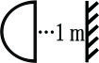
- Fixed installation, to prevent the strong vibration or impact of the device.
- The distance between the device and the projectile to keep at least 1meter.

- Never look directly into the light source,as sensitive persons may suffer an epileptic shock(especially meant for epileptics)!
- When light output position of the device of dustproof glass breakage, cracks or other visible damage, user should replace the new glass to continue to use.

2. Installation
- When install this equipment please make sure there's no flammable surfaces (decorated things, etc) and minimum distance of 0.5M from the equipment to the flammable.

- The installation of the effect has to be built and constructed in a way that it can hold 10 times the weight and without any harming deformation.
- The installation must always be secured with a secondary safety attachment, e.g. an appropriate safety rope.Never stand directly below the device when mounting, removing or servicing the fixture.

3. Product Specification
- Input voltage: AC100-240V
- Fuse: BGDP ￠5X20MM 250VAC T2A
- Power consumption: 40W
- Derby LED: 8PCS 3W RGBY LED， Each color:2pcs
- UV LED: 8PCS 3W
- White LED: 2PCS 3W
- Laser: 30mW/532nm green +80mW/650nm red
- Control mode: sound/auto/DMX/Master-slave/remote control
- Working Temp: 10-40℃
- DMX channels: 10CH & 2CH
- Net weight: 2.4KG
- Gross weight: 3.1KG
- Box dimension: 31*29*26cm
- Carton dimension: 64*60*55cm (8boxes / carton)

- LED Display
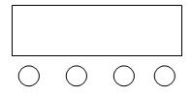
E
A B C D

A．（MENU）
B．（UP）
C．（DOWN）
D．（ENTER）
E．LED Display

LED Display Menu Operation:

 | MENU | UP/DOWN | DEFAULT VALUE | FUNCTION
1 | Addr | 1-512 | 1 | Set DMX address
2 | ChMd | 10Ch | 10Ch | 10CH mode
2 | ChMd | 2Ch | 10Ch | 2CH mode
3 | ShNd | Sh 1 | Sh 4 | Show 1
3 | ShNd | Sh 2 | Sh 4 | Show 2
3 | ShNd | Sh 3 | Sh 4 | Show 3
3 | ShNd | Sh 4 | Sh 4 | Show 1-3 (by random)
4 | SPEE | 0-100 | 90 | Sh 1-Sh-4 speed
5 | SLMD | MASt | MASt | Master mode
5 | SLMD | SLAV | MASt | Slave mode
6 | SoUn | ON/OFF | ON | Sound ON/OFF
7 | SoSE | 1-100 | 90 | Set Sensitivity
8 | DNST | MASt | MASt | When no DMX, run master /slave mode
8 | DNST | BLNd | MASt | When no DMX, stand by
8 | DNST | LAST | MASt | When no DMX, keep the last scene
9 | LED | ON/OFF | ON | LED display back light ON/OFF
10 | Test |  |  | Test light function
11 | DISP |  |  | LED display reverse
12 | Fhrs |  |  | Total working time
13 | Ver | V10 |  | Software version
14 | Rset |  |  | Light reset

Remarks: DMX signal takes priority to operate, no matter what mode the light is now, after connecting to DMX controller, the light will enter into DMX mode as master unit, and other units will be slave units automatically.
After finishing menu setting, press MENU and hold it for a long time to enter the work mode we already set, or await 10seconds to enter the work mode we already set.

5.DMX Channel
10CH
 |  | DMX value | function
CH1 | Control mode | 0-9 | No function
CH1 | Control mode | 10-69 | Show 1: spot LED show
CH1 | Control mode | 70-129 | Show 2: UV+white LED show
CH1 | Control mode | 130-189 | Show 3: laser show
CH1 | Control mode | 190-255 | Show 4: all shows by random
CH2 | Spot LED color control | 0-9 | Spot LED OFF
CH2 | Spot LED color control | 10--198 | Color choose (15 options, 13 datas for each option)
CH2 | Spot LED color control | 199-225 | Color flowing 1(single color) slow to fast
CH2 | Spot LED color control | 226-255 | Color flowing 2（several colors）slow to fast
CH3 | Spot LED strobe control | 0-9 | Spot LED strobe OFF
CH3 | Spot LED strobe control | 10-244 | Spot LED strobe speed(slow to fast)
CH3 | Spot LED strobe control | 245-255 | Spot LED strobe with sound control
CH4 | Spot LED control | 0-127 | Spot position choose
CH4 | Spot LED control | 128-255 | Spot scanning(slow to fast)
CH5 | White LED dimmer | 0-255 | white LED dimmer
CH6 | White LED strobe | 0-244 | white LED strobe speed(slow to fast)
CH6 | White LED strobe | 245-255 | white LED strobe with sound control
CH7 | UV LED dimmer | 0-255 | UV LED dimmer
CH8 | UV LED strobe | 0-244 | UV LED strobe speed(slow to fast)
CH8 | UV LED strobe | 245-255 | UV LED strobe with sound control
CH9 | Laser color | 0-9 | Laser off
CH9 | Laser color | 10-62 | Red laser on
CH9 | Laser color | 63-126 | Green laser on
CH9 | Laser color | 127-255 | Red+green on
CH10 | Laser motor | 0-127 | Laser pattern option
CH10 | Laser motor | 128-255 | Laser pattern change speed (slow to fast)

2CH
 |  | DMX value | function
CH1 | Control mode | 0-9 | No function
CH1 | Control mode | 10-69 | Show 1: spot LED show
CH1 | Control mode | 70-129 | Show 2: UV+white LED show
CH1 | Control mode | 130-179 | Show 3: laser show
CH1 | Control mode | 180-255 | Show 4: all shows by random
CH2 | Show speed/sound control | 0-247 | Show 1-Show 4 Speed from slow to fast
CH2 | Show speed/sound control | 248-255 | Show 1-Show 4 sound control

6. Remote controller
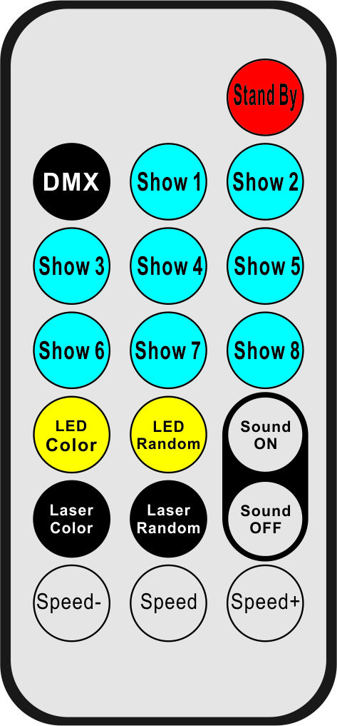
1
2
3
4
6
5
8
7
9
10
11
12
NO | BUTTON | FUNCTION
1 | Stand By | LIGHT STAND BY
2 | DMX | NO FUNCTION
3 | Show 1-Show 8 | Show 1-Show 4(available) ，Show 5-Show 8(no function)
4 | LED Color | LED color choose
5 | LED Random | LED color by random
6 | Laser Color | NO FUNCTION
7 | Laser Random | NO FUNCTION
8 | Sound ON | Sound control ON
9 | Sound OFF | Sound control ON
10 | Speed - | Decrease Show speed
11 | Speed | Set Show’s speed at middle speed
12 | Speed+ | Increase Show speed

7.Installation
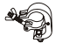
1. Clamp
2 .Handle

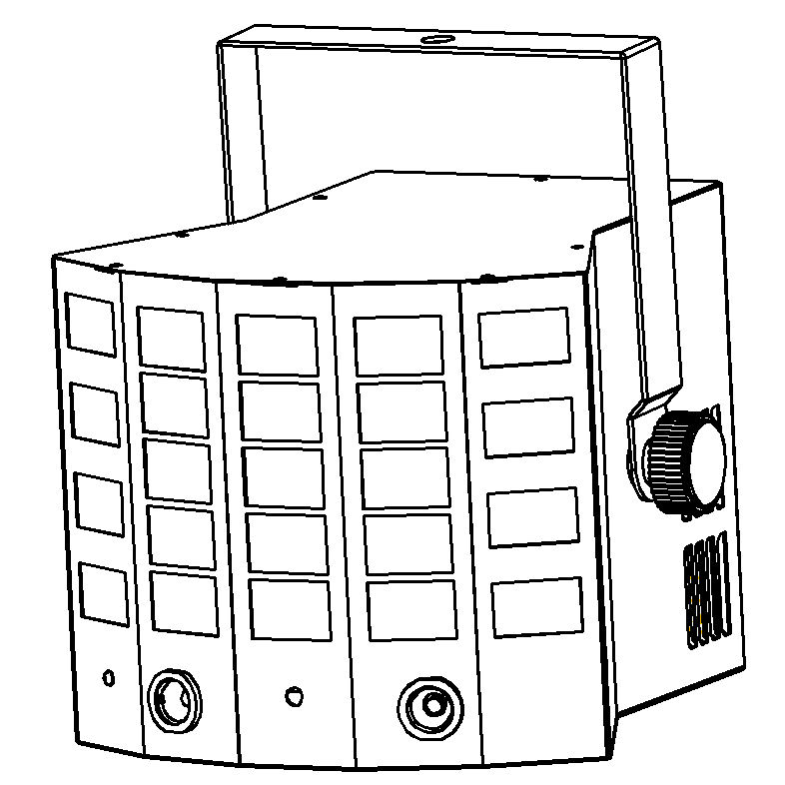
When install this equipment please make sure there's no flammable surfaces (decorated things, etc) within at least 2.5M and maintain minimum distance of 0.5M from the equipment to the walls.

Please make sure that there's no other equipment or decorating materials obstructed the exhaust fan and the vent-pipe.

Products should be install immobility.

In case of safety, it's very important that to connect the earth with line.

8. DMX-512 connection

3 Pin DMX output 3 Pin DMX input
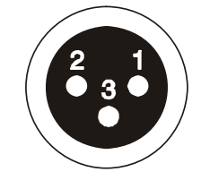
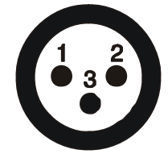

1 Ground 2 Signal - 3 Signal +
Take 10ch as example
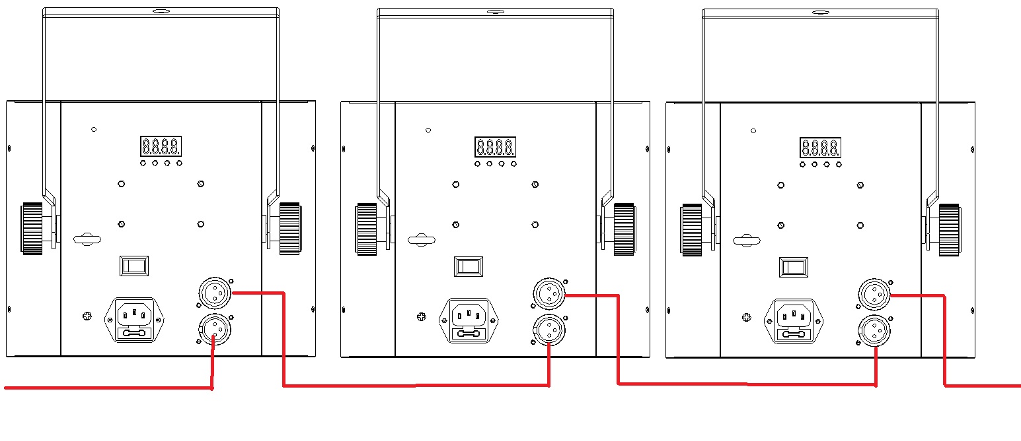
DMX in
DMX out
First one add 001 Second one add 011 Third one add 021

9. DMX address setting
Each fixture must set a specific starting address. When receiving signal, fixture will receive channel control signals of this address from the DMX controller.
For easy to use, the user can set the same address for several fixtures , also can set up a unique address for every device.
If you set the same address for all fixtures, all the fixtures will receive from the same DMX channels signal. All connecting fixtures are jointly controlled, controller can't separately control a device.
If you set a different address for each fixture, each fixture will receive unique signal and can be controlled by DMX controller separately.
This fixture has 14 channels.you should set the starting address of the first unit to 1, the second unit to 11(1*10 + 1), the third unit to 21(2*10+ 1), and so on.

10. Product size
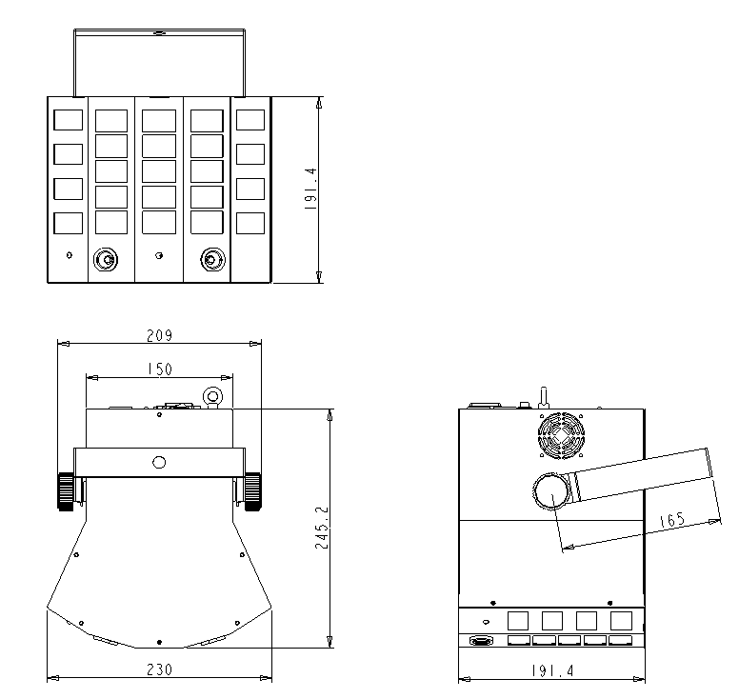

11.Declaration
Cleaning and maintenance

Cleaning should be performed every 15-day period, by using a sponge which is dipped with alcohol, rather than wet cloth or other chemical liquid, to clean the mirror.

Cut off power before cleaning and maintenance!
CAUTION

Attention

Do not see directly light source when open the light, and make sure power off before do any installation or maintenance.

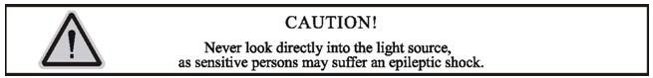
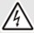 Wires connection must be professional person!
CAUTION

Warranty Card
This product is made of high-brightness transistor. We will provide 1 year warranty under the condition that user has operated the light normally and lifetime service. We won't provide warranty if the damage is caused by artificial or force majeure event. Cost of fittings should be charged by user if product need maintenance after 1 year .Please cut this warranty card and shipped it along with the product to our factory when applying for warranty.
Product： Purchasing date： Code of invoice：
Warranty date: From To
User’s name： Add：
Company： Tel：

